“Support Vector Machine” (SVM) is a supervised machine learning algorithm which can be used for both classification or regression challenges. However,  it is mostly used in classification problems. In this algorithm, we plot each data item as a point in n-dimensional space (where n is number of features you have) with the value of each feature being the value of a particular coordinate. Then, we perform classification by finding the hyper-plane that differentiate the two classes very well (look at the below snapshot).

[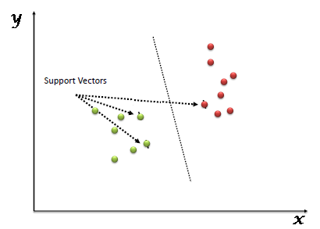](https://www.analyticsvidhya.com/wp-content/uploads/2015/10/SVM_1.png)

Support Vectors are simply the co-ordinates of individual observation. Support Vector Machine is a frontier which best segregates the two classes (hyper-plane/ line).

Compared to newer algorithms like neural networks, they have two main advantages: higher speed and better performance with a limited number of samples (in the thousands). This makes the algorithm very suitable for text classification problems, where it’s common to have access to a dataset of at most a couple of thousands of tagged samples.

|  |  |  |
| --- | --- | --- |
|  |  |  |
| |  |  |  | | --- | --- | --- | |  |  |  | | |  |  |  | | --- | --- | --- | | **Algorithm** |  |  | | 1. Define an optimal hyperplane: maximize margin 2. Extend the above definition for non-linearly separable problems: have a penalty term for   misclassifications.   1. Map data to high dimensional space where it is easier to classify with linear decision surfaces:   reformulate problem so that data is mapped implicitly to this space. |  |  | |  |  | |  |  |